NVC Help
NVC 2.3.0 -- en
Contents
Open this document in Word to build the table of contents.

Introduction
NVC is a Windows video converter built around FFmpeg. It watches a source folder, converts supported media, inspects media information, records up to four sources, plays media side by side, generates a PC report, and can clean up original files after conversion.
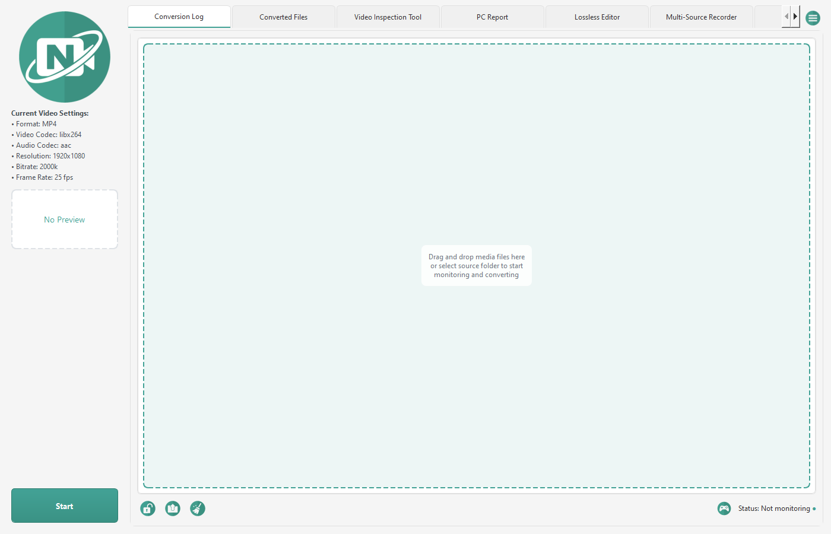
Figure 0. The NVC main window, with the conversion log and preview panel.
Note
- Overwrite policy: NVC never overwrites an already converted video. If the destination already contains video.mp4, the next output becomes video (1).mp4, then video (2).mp4 -- the same style web browsers use for duplicate downloads.

Quick Start
Six steps from a fresh install to a converted file.
- Open Settings from the menu.
- On the Folders tab, choose the Source Folder.
- On the Folders tab, choose the Destination Folder.
- On the Format tab, choose the Output Format, Video Codec and Audio Codec. The defaults suit most cases.
- Click OK, and then click Start.
- Drop videos into the source folder.
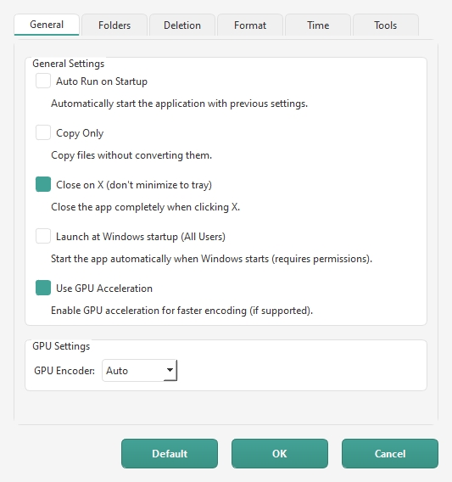
Figure 1. Settings, General tab: startup, Copy Only, tray and GPU options.

Main Window Overview
The main window is organised into tabs, with a shared preview panel and a status footer.
Area | What it does
Video Converter | The Converted Files table (queued, processing, successful and failed conversions) above the conversion log with its messages, progress, warnings and results. Drag the divider between them.
PC Report | Generates a PC report for support and troubleshooting.
Lossless Editor | Provides trim, remux, merge and audio stream-copy tools.
Multi-Source Recorder | Records up to four video sources.
Media Player | Plays media in one, two or four panels, with an Inspect panel showing the selected clip's ffprobe summary and JSON.
Preview Panel | Shows a preview of the current file or recorder layout.
Menu | Opens Info, Help, folders, Settings, Language, updates and Quit.

Note
- PC Report and Lossless Editor are hidden by default. Turn them on in Settings -- Tools. Play or Inspect in Media Player shows the Media Player tab for the current session even when it is switched off.
- The Menu contains Info, Help, Open Source Folder, Open Destination Folder, Open Backup Folder, Settings, Language, Check for Updates and Quit.
- The footer has the Start/Stop button, a lock icon, a file picker, a broom and a status label. On the recorder tab the button reads Start Recording or Stop Recording. The lock icon locks settings, and the Start button then reads Locked. The file picker selects media files to convert, and the broom clears the log.
- Clicking X closes NVC by default. Clear "Close on X (don't minimize to tray)" in Settings -- General to minimise to the system tray instead. The tray menu has Show and Quit. Only one copy of NVC can run at a time.

Converting Files
When monitoring is active, NVC watches the source folder for new supported videos. It also scans existing files in that folder when monitoring starts.
You can drag files onto either half of the Video Converter tab. You can also use the file picker in the footer to select media files to convert.
NVC protects existing converted files. If a converted output name already exists, NVC chooses the next available browser-style filename:
Session.mp4
Session (1).mp4
Session (2).mp4

NVC accepts common video formats including MP4, AVI, WMV, MKV, FLV, WebM, MOV, MPEG, MPG, M4V, 3GP, TS, VOB, RM, RMVB, ASF, M2TS, MTS, OGV, DIVX, DV and F4V.
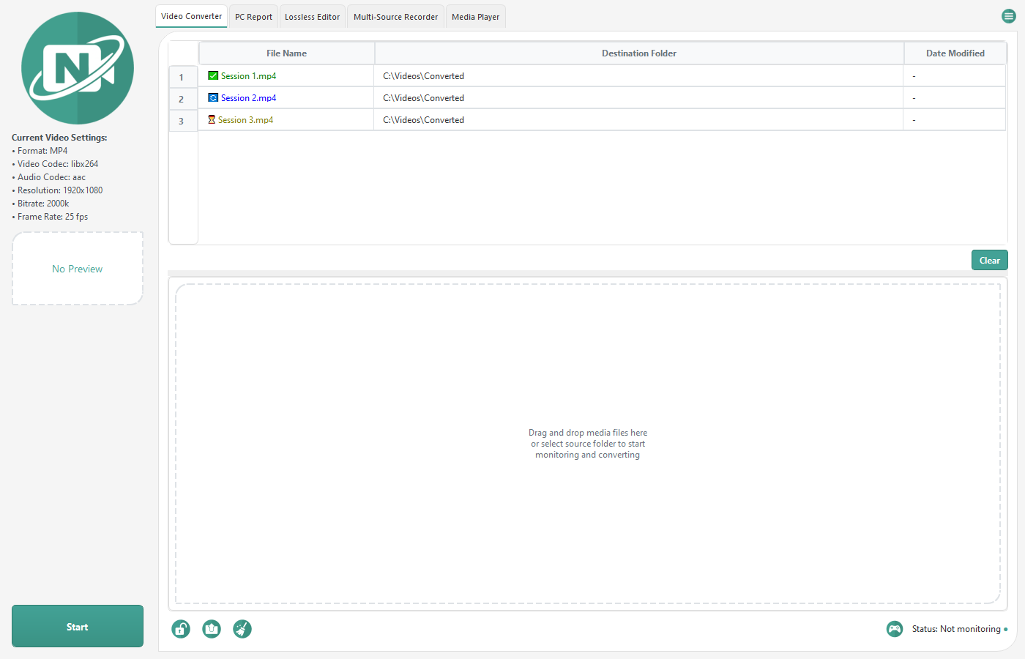
Figure 3. The Video Converter tab: the Converted Files table above the conversion log.

Conversion Settings
Settings has six tabs: General, Folders, Deletion, Format, Time and Tools. Default restores every value, OK saves, and Cancel discards changes.
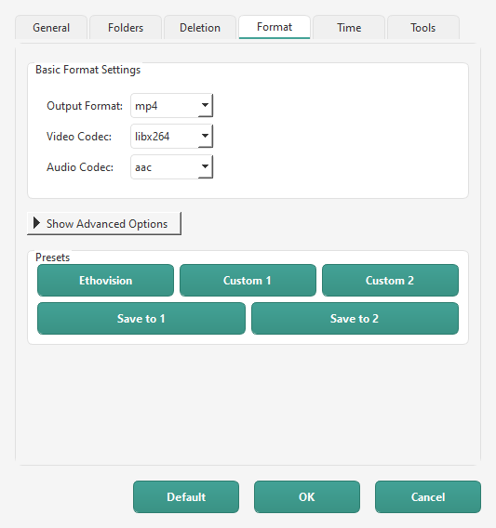
Figure 2. Settings, Format tab: output format, codecs and presets.
The General tab controls application behaviour and GPU encoding.
Setting | Guidance
Auto Run on Startup | Starts monitoring automatically with the previous settings.
Copy Only | Remuxes the source streams into the selected Output Format without re-encoding (FFmpeg -c copy), which is fast but fails when the container cannot hold the source streams. The Lossless Editor's Remux does the same for single files.
Close on X (don't minimize to tray) | Ticked by default. Clear it to minimise NVC to the system tray when you click X.
Launch at Windows startup (All Users) | Launches NVC when Windows starts for all users and requires permission.
Use GPU Acceleration | Enables GPU acceleration when supported.
GPU Encoder | Choose Auto, nvidia, intel or amd.

The Folders tab selects the folders used by NVC.
Setting | Guidance
Source Folder | Click Change to select the folder NVC watches and scans.
Destination Folder | Click Change to select where converted files are written.
Backup Folder | Click Change to select where backed-up originals are moved.
Log Folder | Shows the log location. NVC currently always writes logs to %APPDATA%\NVC\logs; changing this field has no effect in this version.

The Deletion tab controls original files. See the Original File Handling chapter.
The Format tab controls the conversion output.
Setting | Guidance
Output Format | Choose mp4, mov, avi, mkv, flv, webm, mpeg, mpg, 3gp, ogg, wmv, m4v, mp3 or gif.
Video Codec | Choose libx264, mpeg4, libvpx, hevc, flv, libtheora or wmv2.
Audio Codec | Choose aac, mp3, ac3, opus or vorbis.
GIF options | FPS, Max Width, Loop and Quick GIF (no palette) appear when Output Format is gif.
Show Advanced Options | Shows Video Size, Bitrate, Frame Rate, Keyframe Interval (GOP), Volume, Text Overlay and Console Integration.
Video Size | Choose Auto, 640x480, 1280x720, 1920x1080 or 3840x2160.
Bitrate | Choose Auto or a listed value from 512k to 3000k.
Frame Rate | Choose Auto or a listed rate from 8 to 60.
Keyframe Interval (GOP) | Choose 0 for Auto or a value up to 300.
Volume | Set output audio volume from 0 to 500 %.
Text Overlay | Adds text to the output. See the Text Overlays chapter.
Console Integration | Appends custom FFmpeg flags to the command.
Presets | Use Ethovision, Custom 1, Custom 2, Save to 1 or Save to 2.

The Time tab limits when conversion may start.
Setting | Guidance
No Time Restrictions | Allows conversion at any time.
Start Time | Sets the start of the allowed conversion window.
End Time | Sets the end of the allowed conversion window. See Time Restrictions.

The Tools tab controls which tool tabs appear in the main window.
Setting | Guidance
Tool checkboxes | There is one checkbox for each tool tab. Unticked tabs are hidden from the main window.

GPU Encoding
If enabled, NVC attempts to use a supported GPU encoder for NVIDIA, AMD or Intel hardware. GPU encoding can be much faster than CPU encoding, but the available codecs depend on your installed GPU drivers and FFmpeg build.
H.264 GPU encoders: h264_nvenc h264_amf h264_qsv
HEVC GPU encoders: hevc_nvenc hevc_amf hevc_qsv

Note
- If the selected GPU encoder is unavailable, NVC falls back to CPU encoding where possible.
- Detection runs once per session and is cached. If you install new GPU drivers, restart NVC so it re-detects the available encoders.

GIF Export
GIF output can use a two-pass palette workflow for better colour quality. You can adjust FPS, Max Width and Loop, or select Quick GIF (no palette). A lower FPS and a smaller Max Width both reduce file size.
Note
- GIF files grow quickly. For long clips, convert to MP4 instead.

Text Overlays
Text Overlay burns the selected text into the output video.
Overlay | Shows
None | No overlay.
Elapsed Time | The elapsed playback time.
Recorded Time | The recorded time of day.
Recorded Date/Time | The recorded date and time.
Recorded Date/Time + Remaining | The recorded date and time on one line and remaining seconds on another.
CRTV Cam | A blinking REC label and the recorded time.

Note
- Overlays require video filtering and may reduce GPU compatibility and conversion speed.
- Recorded overlays use the file's recorded time when present and otherwise use the file modified time.

Original File Handling
Option | Behaviour
Delete files after conversion | Deletes the original after a successful conversion, immediately when retention is 0 or after the retention period.
Retention time (days) | Choose 0 to 30 days. Pending deletions are stored on disk and processed after a restart.
Use Backup Folder | Moves originals to the Backup Folder instead of deleting them.

Note
- Keep originals until you have confirmed the converted files play correctly.

Time Restrictions
Settings -- Time lets you select No Time Restrictions or set a Start Time and End Time for conversion.
Note
- A file detected outside the window is skipped with "Current time outside allowed range" in the conversion log. It is not queued for later. Drop the file again, or let monitoring re-detect it, inside the permitted window.
- An End Time earlier than the Start Time means an overnight window.
- The default is No Time Restrictions.

Video Converter: Converted Files
The Video Converter tab shows the Converted Files table above the conversion log; drag the divider between them to change the split. The table has File Name, Destination Folder and Date Modified columns. Status icons identify queued, processing, successful and failed conversions. Play and Inspect are buttons below the table; they appear once a row is selected. The remaining actions are on the row's right-click menu. The broom in the footer clears the log; Clear empties the table.
Control | What it does
Play | Opens the selected file in the Media Player tab.
Inspect | Opens the selected file in the Media Player with the Inspect panel showing its ffprobe details.
Play in Media Player | Opens the selected file in the Media Player tab.
Inspect in Media Player | Same as the Inspect button.
Open Containing Folder | Opens the selected file's destination folder.
Open Log File | Opens a dialog containing the per-file conversion log.
Copy File Path | Copies the selected file path.
Settings | Opens Settings.

Media Inspection
Media inspection lives in the Media Player: the Inspect panel beside the video (open by default; the magnifier button on the transport bar hides and shows it) has Summary and Detailed JSON sub-tabs for the selected panel's clip. Selecting another panel, or loading a different file into the selected one, updates it. Drag the divider between the video and the panel to resize it; the panel keeps its share of the window as the window grows. Drop a file on either sub-tab to inspect that file without loading it. Summary lists File, Container, Duration, Size, Bitrate and Number of Streams. It then lists each video, audio and subtitle stream, including its codec and the applicable resolution, frame rate or channels. A Keyframe Analysis (First 30s) block follows the stream details. Detailed JSON shows the raw ffprobe -print_format json output.
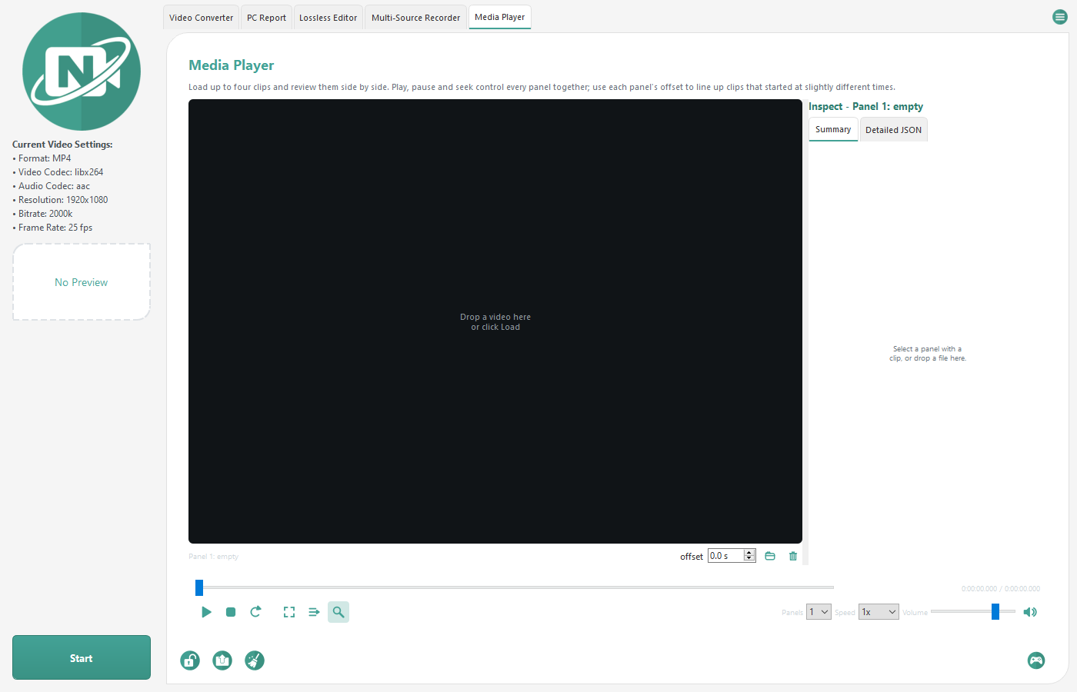
Figure 4. The Media Player's Inspect panel beside the video, Summary sub-tab.

PC Report Tool
The PC Report tool gathers system information for support and troubleshooting.
- Click Generate PC Report.
- Wait for collection to finish. Some collectors can take a while.
- Click Open Report to open the generated HTML. Open Folder opens whichever folder the report was written to.
- Reports are saved to your Desktop by default, with the path pattern Desktop\PC_Report_YYYYMMDD_HHMMSS.html. If there is no Desktop folder, NVC uses your user profile folder instead. If that file name already exists, NVC chooses a unique name and never overwrites the existing file.
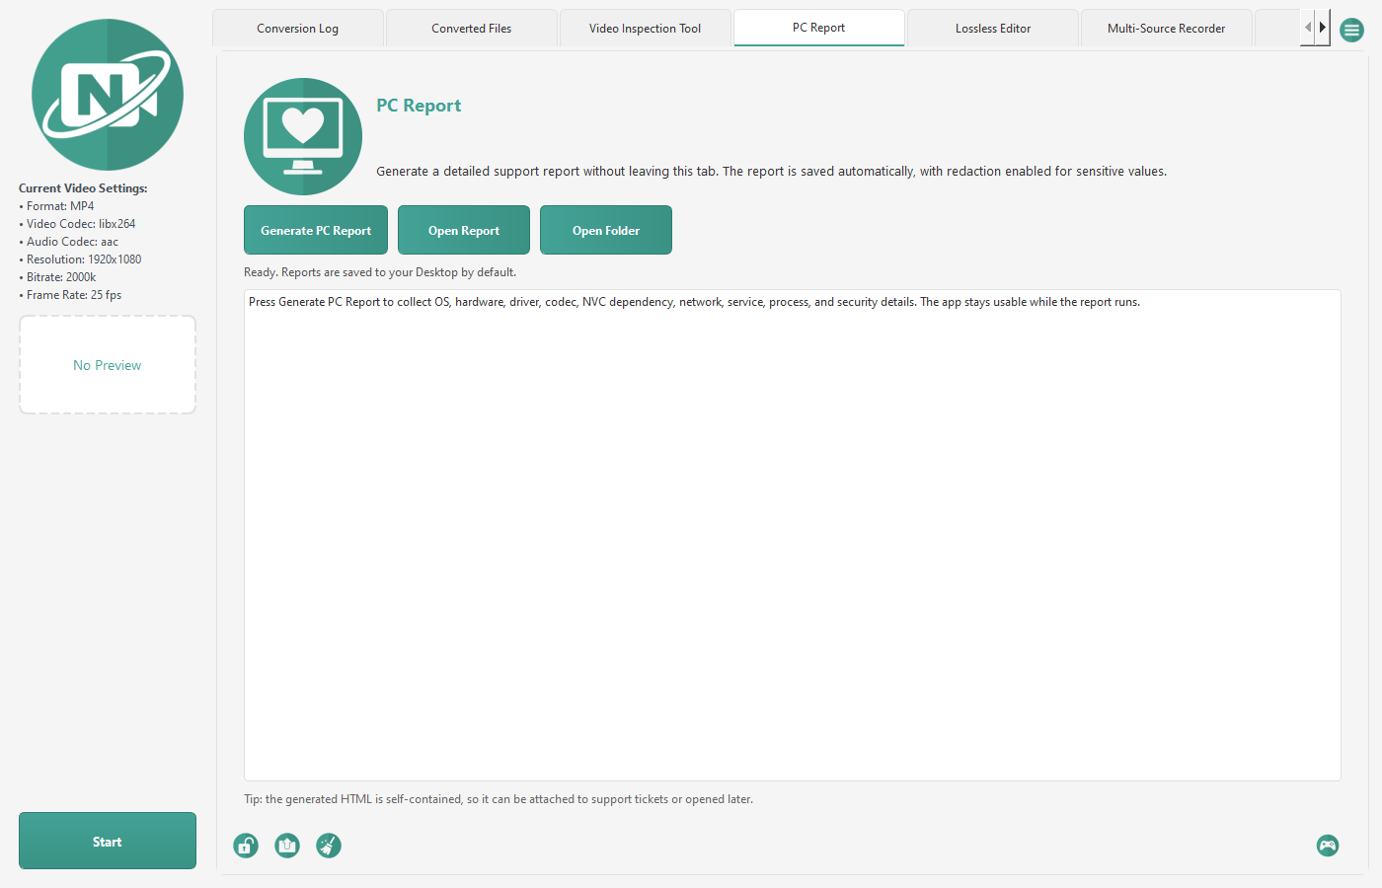
Figure 5. The PC Report tab before a report is generated.
The report opens with Report Health (timing, empty sections and warnings) and then these sections:
Noldus Summary
Operating System
Installed Updates
Licenses
System Directories
System Files
Installed Programs
Security
Accessibility
Environment
Regional Settings
Processes
Services
Drivers
Autorun
Codecs
MMC Snap-ins
System Summary
Motherboard
BIOS
CPU
Memory
Sensors
Devices
PCI
System Slots
Network Adapters
Video
Monitors
Sound
Storage Devices
Logical Disks
Ports
USB
Printers
Virtual Machine
Cameras
Network Information
Shares
Network Connections

Note
- Redaction is always on. NVC masks serial numbers, licence keys, passwords and tokens, user and machine names, hostnames, IP and MAC addresses, proxy settings, UNC paths and user profile paths. Review a report before sharing it anyway.
- Some values need administrator rights and show "Requires administrator" when NVC runs normally. Right-click NVC and choose Run as administrator for a complete report.
- Drivers, devices, network connections and processes are the slow collectors on large systems.

Lossless Editor
The Lossless Editor tab provides FFmpeg stream-copy tools. These operations are fast because they avoid re-encoding wherever possible. Output container choices are mp4, mkv, mov, avi and m4a; Extract Audio always uses m4a.
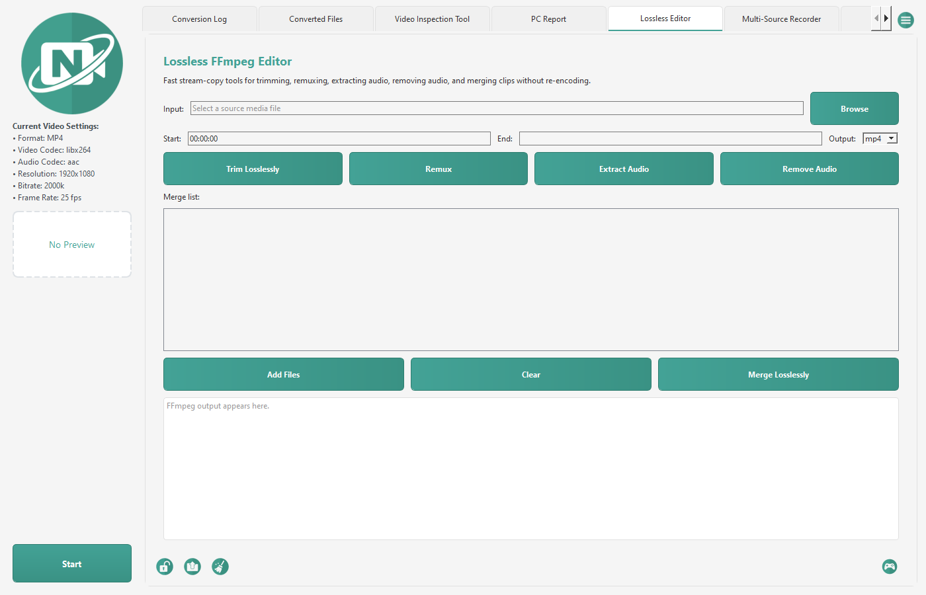
Figure 6. The Lossless Editor tab with its trim, remux and merge tools.
Operation | What it does
Trim Losslessly | Cuts a section between start and end timestamps using stream copy.
Remux | Rewraps media into mp4, mkv, mov or avi without re-encoding.
Extract Audio | Writes the first audio stream to an audio-only m4a file.
Remove Audio | Writes a silent, video-only copy.
Merge Losslessly | Joins compatible clips using the FFmpeg concat demuxer.
Add Files | Adds source clips to the merge list.
Clear | Removes every source clip from the merge list.

Note
- Lossless operations need compatible codecs and containers. If FFmpeg fails, the source streams may need re-encoding, or a different output container.
- A lossless trim can only cut on a keyframe, so the actual start may shift slightly earlier than the timestamp you enter.

Multi-Source Recorder
The Multi-Source Recorder records up to four sources at once with FFmpeg. The tab shows one row per source; configure the sources in the Video Settings dialog.
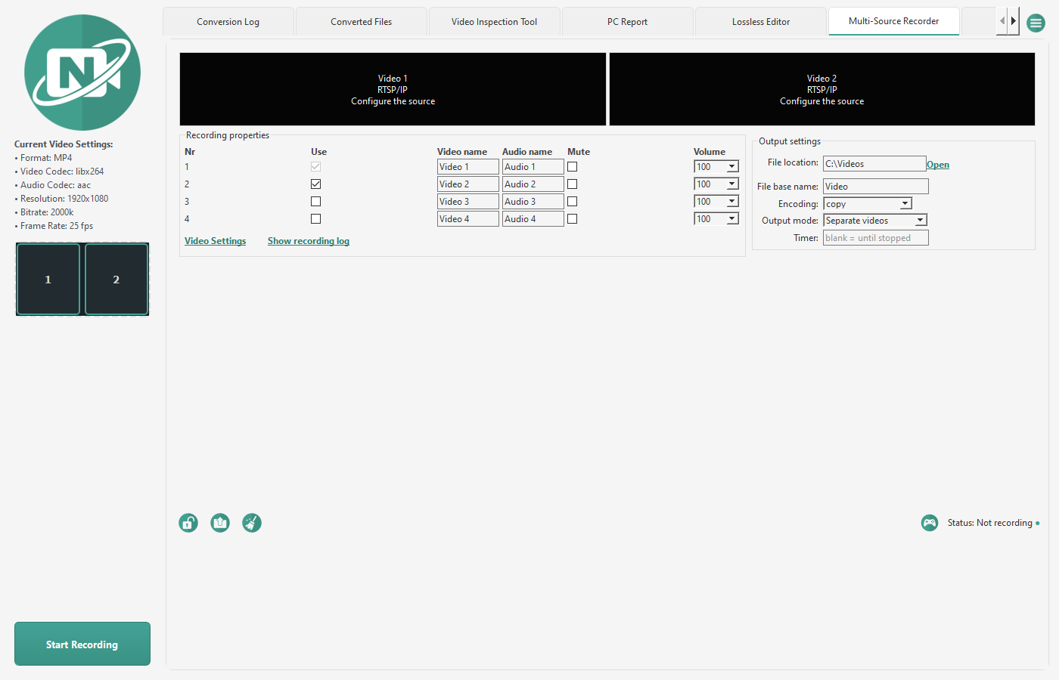
Figure 7. The Multi-Source Recorder tab with two sources enabled.
The recorder tab
Control | What it does
Use | Records this row.
Video name | Sets the label used in the file name.
Audio name | Sets the audio label for the row.
Mute | Records the row without sound.
Volume | Sets the audio level to 100, 75, 50, 25 or 0 %.
Encoding | copy keeps the source's own compressed video only for RTSP, stream and file sources. USB (DirectShow) cameras are always re-encoded with H.264 regardless of the Encoding choice.
Output mode | Separate videos writes one file per row; Combined grid writes one file with all sources tiled.
File location | Sets the recording folder. The default is your Videos folder.
File base name | The default is Video. Separate videos, and Combined grid with one enabled source, use <base>_<Video name>_<timestamp>.mp4. Combined grid with more than one enabled source uses <base>_Combined_<timestamp>.mp4.
Timer | The field shows "blank = until stopped"; leave it blank to record until you press Stop Recording.
Show recording log | Opens the recording log.
Start Recording / Stop Recording | The footer button starts or stops recording.

Video Settings
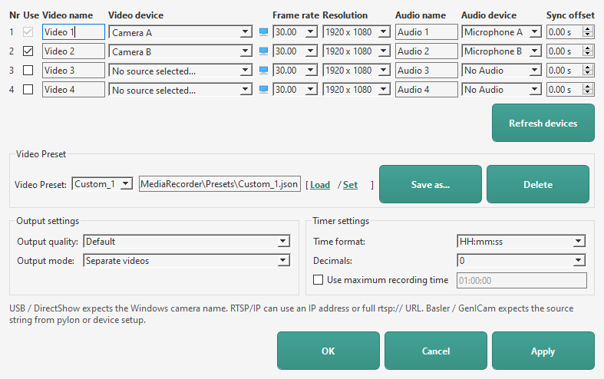
Figure 9. The recorder's Video Settings dialog with two camera rows configured.
- Open Video Settings. Each row has Use, Video name, Video device, a camera settings button, Frame rate, Resolution, Audio name, Audio device and Sync offset.
- In Video device choose a USB camera by its Windows name, choose RTSP/IP Camera and click the camera button to enter Address / URL, Username, Password, Port and Stream path, or type an rtsp://, http:// or https:// URL, a file path, or a Basler / GenICam source string directly. Refresh USB devices... rescans. The camera dialog refuses an Address that looks like an IP but is not one (a number over 255, or three or five numbers); if a saved address is wrong, the preview tile reads "Cannot resolve the camera address" instead of reconnecting -- open Video Settings and correct it.
- The default Frame rate list is 30.00, 25.00 and 15.00; the default Resolution list is 1920 x 1080, 1280 x 720, 640 x 480 and Auto. When a USB camera is selected, NVC replaces both lists with the modes the driver reports and adds Auto to each. If detection fails, the lists are left as they were: leave Resolution at Auto and choose a frame rate the camera supports. Auto is only offered for Frame rate after successful detection.
- Choose an Audio device per row, or No Audio. Refresh devices rescans microphones. Mute or Volume 0 on the tab records that row without sound.
- Sync offset shifts a source earlier or later in a Combined grid recording so clips that started at slightly different times line up.
- Apply keeps the dialog open; OK applies and closes.
Presets
- Load applies the selected preset; Set overwrites it with the current settings; Save as... creates a new one; Delete removes it. An asterisk after the name marks unsaved changes.
- Presets are JSON files under Public\Documents\Noldus\NVC\MediaRecorder\Presets.
Control from the command line
Another program can start and stop a recording by running NVC.exe with a switch. The switches are the same letters MediaRecorder's MRCmd.exe uses, so entries in The Observer XT's external applications list can be reused with NVC.exe as the program. If NVC is already running the switch is passed to it; if not, /E, /R, /C and /B start NVC first, while /S and /X do nothing.
Switch | What it does
/E | Starts NVC, or brings the running NVC to the front.
/R | Starts recording with the current recorder settings.
/S | Stops the recording.
/X | Stops any recording and closes NVC.
/C=name | Loads the video preset with that name, or from a .json file path.
/B=name | Sets the recording file base name.

- Switches combine and always run in the order preset, base name, record, stop, close. Example: NVC.exe /E /C=Lab1 /B=Trial07 /R
- Put a value with spaces in quotes: NVC.exe "/C=Two cameras".
- The process exits with code 0 when the request succeeded and 1 when it did not, for example when NVC is locked, a conversion is running, or the preset does not exist. The reason is written to the console and to the conversion log.
Note
- Without a microphone, a file or RTSP source in h264 mode keeps its own sound track; in copy mode an RTSP source is recorded without audio; a USB camera without a microphone is silent. Combined grid takes its audio from the first enabled, unmuted row with a microphone.
- A saved microphone that is not connected shows as (not found). If the audio device fails as recording starts, NVC restarts that row as video only and says so in the recording log, so the camera recording is not lost.
- FFmpeg needs the exact Windows camera name; close other applications that may be using the camera.

Media Player
The Media Player loads up to four clips for synchronized review. The tab is hidden by default; enable it under Settings -> Tools. Play in Media Player from Converted Files shows the tab for the current session, loads the selected file and starts playback.
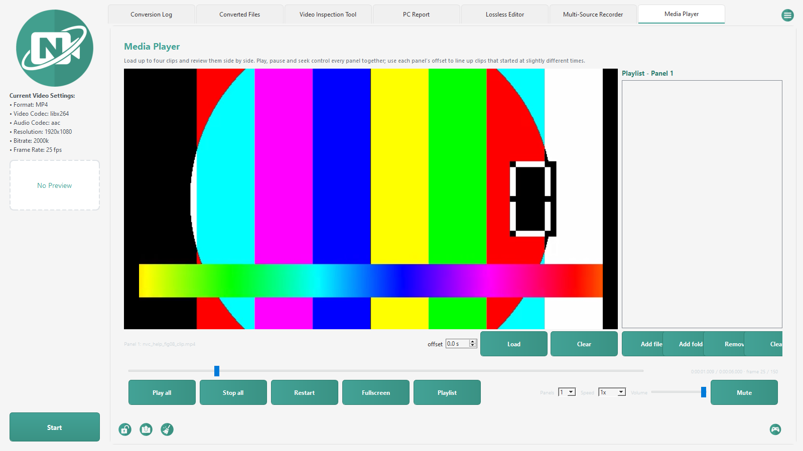
Figure 8. The Media Player tab with a clip loaded in a single panel.
Control | What it does
Load | Loads a clip into that panel.
Clear | Removes the clip from that panel.
offset | Shifts that panel in seconds relative to the shared seek position.
Play all | Plays every visible loaded panel and reads Pause all while playing.
Stop all | Stops every loaded panel and returns the shared position to zero.
Restart | Returns to the beginning and plays every visible loaded panel.
Seek slider | Moves every visible loaded panel on the shared timeline.
Speed | Sets every panel to 0.25x, 0.5x, 1x, 1.5x or 2x playback.
Panels | Shows 1, 2 or 4 panels.
Volume | Sets the volume for every panel from 0 to 100.
Mute | Mutes every panel and reads Unmute while muted.
Fullscreen | Shows the panels and transport bar fullscreen; the Inspect and Playlist panels step aside until you leave.
Playlist | Shows or hides the playlist strip under the video for the selected panel.
Inspect | Shows or hides the Inspect panel beside the video (see Media Inspection).

The readout shows H:MM:SS.mmm / H:MM:SS.mmm · frame N / M. NVC reads the clip's real frame rate with FFprobe, so Left and Right step exactly one frame. Frame stepping pauses playback.
Keys | Action
Space | Play or pause
Home | Restart from the beginning
Left | Step back one frame
Right | Step forward one frame
Shift+Left | Seek back 5 seconds
Shift+Right | Seek forward 5 seconds
Up | Volume up 5
Down | Volume down 5
M | Mute or unmute
F | Toggle fullscreen
Escape | Leave fullscreen
N | Next playlist item
P | Previous playlist item

Shortcuts work while the Media Player tab has focus. Press F, click Fullscreen, or double-click a panel to enter fullscreen. The transport bar hides three seconds after the mouse stops moving and returns when the mouse moves. Press Escape or F, or double-click, to leave fullscreen.
Playlist opens a strip under the video for the selected panel with Add files..., Add folder..., Remove and Clear. Drag entries to reorder them, or drop files from Explorer into the strip. N and P move through the playlist. With Panels set to 1, the next item starts automatically when a clip ends.
A clip shows its first frame as soon as it is loaded or dropped onto a panel (the tile reads Loading... for a moment), and the seek slider moves the picture before you press Play. The sidebar preview on the left follows the selected panel's clip.
Note
- A file Windows cannot decode shows "Windows cannot play this file." or names the codec and container, with "Convert to MP4 (H.264) and play". The converted copy is written to your Destination Folder with a unique name and then loaded.
- NVC remembers the last folder, panel count, volume, mute and whether the Inspect and Playlist panels were open between sessions.
- Playback uses Windows Media Foundation. MP4, MOV, MKV, AVI and WMV files with common codecs play directly; use the convert offer for anything else.

Language
Menu -- Language lists English, Nederlands and Simplified Chinese; the last entry appears in the menu in Chinese characters. NVC saves the choice and says "NVC will show <language> the next time it starts." The manuals are in English.

Updates and Logs
Item | Where / what
Check for Updates | Open it from the menu. A build without an update address answers "Updates Not Configured". When an address is configured and a newer version exists, "Update v<version> Available!" appears in the sidebar.
Log file | All logs are under %APPDATA%\NVC\logs. The rotating application log is conversion_log.txt, and each conversion has an <output file name>.txt log.
NVC_LOG_LEVEL | Set this environment variable to DEBUG to record full tracebacks.
Settings file | %APPDATA%\NVC\config.json.
Default media folders | Public\Documents\Noldus\NVC\Source, Public\Documents\Noldus\NVC\Destination and Public\Documents\Noldus\NVC\Backup.
Recorder presets | Public\Documents\Noldus\NVC\MediaRecorder\Presets.

Troubleshooting
Problem | What to try
Missing FFmpeg or FFprobe | Make sure ffmpeg.exe and ffprobe.exe are present alongside the app files.
Conversion fails immediately | Check the conversion log. Invalid codec and container combinations, and custom FFmpeg flags, are the common causes.
Output file already exists | NVC creates a numbered filename automatically. Check the destination folder for (1), (2), and so on.
GPU option does not work | Update your GPU drivers, confirm FFmpeg supports your encoder, or disable GPU encoding to fall back to the CPU.
App appears idle after dropping a file | Confirm the app is unlocked, monitoring is started, and the file extension is supported.
PC report is slow | Drivers, devices, network connections and processes are the slow collectors on large systems. Let them finish.
Camera: Could not find video device | FFmpeg needs the exact Windows camera name. Pick it from the Video device list rather than typing it, and close other applications that may hold the camera.
Microphone shows (not found) | The saved microphone is not connected. Plug it in and click Refresh devices, or choose another device or No Audio.
Recording has no sound | Check Mute and Volume on the tab and the Audio device in Video Settings. If the audio device failed at start, NVC recorded video only and says so in the recording log.
Media Player says Windows cannot play this file | The codec or container is not supported by Windows Media Foundation. Click Convert to MP4 (H.264) and play.
A tool tab is missing | Open Settings, Tools tab, and tick it.
Help menu says the document was not found | The generated manual must sit in docs/help, a help folder, or next to the executable. Rebuild it with python docs/help/source/build_help_docs.py.
Something failed with no message | Set the NVC_LOG_LEVEL environment variable to DEBUG and reproduce the problem. NVC then records the full traceback for errors it would otherwise handle quietly.

NVC stores logs under %APPDATA%\NVC\logs: conversion_log.txt is the rotating application log, and each conversion has an <output file name>.txt log that Converted Files -- Open Log File opens.

Best Practices
- Use a dedicated source folder and destination folder.
- Keep originals until you have confirmed the converted files play correctly.
- Use MP4 with H.264 and AAC for the broadest compatibility.
- Use HEVC only when smaller files matter and the target players support it.
- Review PC reports before sharing them.
- Keep custom FFmpeg flags simple, and test them on a small file first.
- Save a recorder preset for each camera setup so a session starts with one Load.
- Review recordings with Panels set to 1 when you want the playlist to advance automatically.

Frequently Asked Questions
Question | Answer
Will NVC overwrite my converted videos? | No. NVC creates a numbered filename when an output already exists.
Can I convert files while monitoring is stopped? | Dropped files may be queued and processed when monitoring starts, depending on where they are dropped. Files can also be force-converted through the drag-and-drop paths meant for manual conversion.
Why did my HEVC file fail to play somewhere? | HEVC is efficient but less universally supported than H.264. If compatibility matters, use H.264.
Where are logs stored? | Every log is under %APPDATA%\NVC\logs: conversion_log.txt is the rotating application log, with one <output file name>.txt log per conversion.
Can I run two copies of NVC at once? | No. NVC allows a single instance, so two copies cannot process the same source folder.
Where do recordings go? | The File location on the recorder tab, your Videos folder by default, named <base>_<Video name>_<timestamp>.mp4 or <base>_Combined_<timestamp>.mp4.
Why does my MKV not play in the Media Player? | Windows Media Foundation does not decode every codec. Use Convert to MP4 (H.264) and play; the copy goes to your Destination Folder.
Can I record without a microphone? | Yes. Choose No Audio, or Mute the row. A file or RTSP source in h264 mode keeps its own sound track.
Why does the PC report say Requires administrator? | Some Windows data is only readable elevated. Run NVC as administrator for a complete report; redaction still applies.

Glossary
Terms used throughout this guide. FFmpeg terminology is kept where it is what you will see in the conversion log.
Term | Meaning
Container | The file wrapper that holds video and audio streams, such as MP4, MKV or AVI. The container is what the file extension names; it is separate from the codec used inside it.
Codec | The scheme used to compress a stream. H.264 (libx264) and HEVC (libx265) are video codecs; AAC and MP3 are audio codecs.
FFmpeg | The command-line media tool NVC runs to do the actual conversion. Its output is what appears in the conversion log.
FFprobe | FFmpeg's inspection tool. NVC uses it to read duration, streams, codecs and other metadata without converting anything.
Stream copy | Rewriting media into a new container without re-encoding it. Fast and lossless, but only possible when the target container supports the existing streams. Also called remuxing.
Remux | Changing a file's container while keeping its streams untouched. See stream copy.
Transcode | Decoding and re-encoding a stream, which changes quality and takes significantly longer than a stream copy.
Keyframe | A frame stored in full rather than as a difference from its neighbours. Seeking and lossless trimming can only land cleanly on a keyframe.
GOP | Group of Pictures: the interval between keyframes. A shorter GOP makes scrubbing more precise at the cost of file size.
Bitrate | Data used per second of media, usually in kbps or Mbps. Higher bitrate generally means better quality and a larger file.
GPU encoding | Using dedicated video hardware (NVENC on NVIDIA, AMF on AMD, Quick Sync on Intel) to encode instead of the CPU. Much faster, with codec support depending on your drivers.
DirectShow | The Windows capture interface NVC uses to record from local devices. Sources are written as video=Device Name.
Media Foundation | The Windows playback framework the Media Player uses to decode and play supported media.
RTSP | A streaming protocol used by most IP and network cameras. Sources are written as a URL, such as rtsp://192.168.1.10/stream.
GenICam | The generic camera interface used by Basler and other industrial cameras. Configure these cameras in Basler pylon Viewer.
Preset | A saved recorder configuration stored as JSON under Public\Documents\Noldus\NVC\MediaRecorder\Presets.
Sync offset | A time adjustment that shifts one source earlier or later in a Combined grid recording so sources line up.
Frame step | Moving exactly one frame forward or backward using the clip's frame rate.
Playlist | An ordered list of media files for one Media Player panel. With one panel, the next item starts automatically.
Administrator (elevation) | Running NVC with administrator rights so the PC report can read protected Windows data.
Tool tab | A main-window tab that can be hidden or shown in Settings -- Tools.
Retention period | How long NVC keeps an original file after a successful conversion before deleting it. Pending deletions survive a restart.
Redaction | Always-on masking of sensitive values such as licence keys, serial numbers, MAC addresses and user paths in a PC report before it is shared.

